# 

**ASSIGNMENT ON ENVIRONMENTAL SCIENCE**

**COURSE TITLE:**ENVIRONMENT FROM THE PROSPECTIVE OF   
QURAN O SUNNAH  
**BS 3 YEARS 5th SEMESTER PROGRAM MORNING**   
**DEPARTMENT:**QURAN & SUNNAH **SUBMITTED TO:**MISS KANWAL  
**SUBMITTED BY:**SHAHNILA ABID  
**SEAT NO:**

B21173006043

# Preview:

The word environment means everything around us which includes both living things and non-living things. But now modernism and social development have destroyed the environment. Climate have been changing continuously and becoming harmful for human health and nature. However Islam has declared purity and a healthy living environment as the fundamental principle of life.

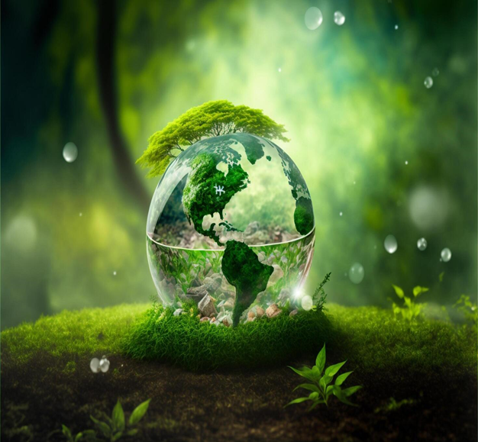

**INTRODUTION:**

* Islam has regarded cleanliness as the basic aspect of life and considered cleanliness as half of the Muslims faith.

Abu Malik at_Ash’ri reported the messenger of Allah(May Peace Be Upon Him) said:

***“Cleanliness is half of faith”***

* No Holy Book has spoken about nature and the earth as much as Quran. Many Surah’s of the Holy Quran have been read in the name of one of the elements of nature, such as Najm, Fajr, Lail, Qamar, Noor and Shams. The Quran has given guidance on maintaining the health of nature and the rest of God’s creation.